Practice problems for chapter 5:

R3. What are some of the possible services that a link-layer protocol can offer to the network layer? Which of these link-layer services have corresponding services in IP? In TCP?
Framing: there is also framing in IP and TCP; link access; reliable delivery: there is also reliable delivery in TCP; flow control: there is also flow control in TCP; error detection: there is also error detection in IP and TCP; error correction; full duplex: TCP is also full duplex.

R11. Why is an ARP query sent within a broadcast frame? Why is an ARP response sent within a frame with a specific destination MAC address?
An ARP query is sent in a broadcast frame because the querying host does not know which adapter address corresponds to the IP address in question. For the response, the sending node knows the adapter address to which the response should be sent, so there is no need to send a broadcast frame (which would have to be processed by all the other nodes on the LAN).

R4. Suppose two nodes start to transmit at the same time a packet of length L over a broadcast channel of rate R. Denote the propagation delay between the two nodes as dprop. Will there be a collision if dprop < L/R? Why or why not?
There will be a collision in the sense that while a node is transmitting it will start to receive a packet from the other node.

P11. Suppose four active nodes—nodes A, B, C and D—are competing for access to a channel using slotted ALOHA. Assume each node has an infinite number of packets to send. Each node attempts to transmit in each slot with probability p. The first slot is numbered slot 1, the second slot is numbered slot 2, and so on.
- What is the probability that node A succeeds for the first time in slot 5?

(1 – p(A))4 p(A)
where, p(A) = probability that A succeeds in a slot
p(A) = p(A transmits and B does not and C does not and D does not)
= p(A transmits) p(B does not transmit) p(C does not transmit) p(D does not transmit) = p(1 – p) (1 – p)(1-p) = p(1 – p)3
Hence, p(A succeeds for first time in slot 5) =
(1 – p(A))4 p(A) = (1 – p(1 – p)3)4 p(1 – p)3

- What is the probability that some node (eitherA,B,CorD) succeeds in slot 4?
p(A succeeds in slot 4) = p(1-p)3
p(B succeeds in slot 4) = p(1-p)3
p(C succeeds in slot 4) = p(1-p)3
p(D succeeds in slot 4) = p(1-p)3
p(either A or B or C or D succeeds in slot 4) = 4 p(1-p)3 (because these events are mutually exclusive)

- What is the probability that the first success occurs in slot 3?
p(some node succeeds in a slot) = 4 p(1-p)3
p(no node succeeds in a slot) = 1 - 4 p(1-p)3
Hence, p(first success occurs in slot 3) = p(no node succeeds in first 2 slots) p(some node succeeds in 3rd slot) = (1 - 4 p(1-p)3)2 4 p(1-p)3

- What is the efficiency of this four-node system?
efficiency = p(success in a slot) =4 p(1-p)3

P18. Suppose nodes A and B are on the same10Mbps broadcast channel, and the propagation delay between the two nodes is 325 bit times. Suppose CSMA/CD and Ethernet packets are used for this broadcast channel. Suppose node A begins transmitting a frame and, before it finishes, node B begins transmitting a frame. Can A finish transmitting before it detects that B has transmitted? Why or why not? If the answer is yes, then A incorrectly believes that its frame was success- fully transmitted without a collision. Hint: Suppose at time t = 0 bits, A begins transmitting a frame. In the worst case, A transmits a minimum-sized frame of 512 + 64 bit times. So A would finish transmitting the frame at t = 512 + 64 bit times. Thus, the answer is no, if B’s signal reaches A before bit time t = 512 + 64 bits. In the worst case, when does B’s signal reach A?
At t  0 A transmits. At t  576 , A would finish transmitting. In the worst case, B begins transmitting at time t=324, which is the time right before the first bit of A’s frame arrives at B. At time t=324+325=649 B 's first bit arrives at A . Because 649> 576, A finishes transmitting before it detects that B has transmitted. So A incorrectly thinks that its frame was successfully transmitted without a collision.

P31. In this problem, you will put together much of what you have learned about Internet protocols. Suppose you walk into a room, connect to Ethernet, and want to download a Web page. What are all the protocol steps that take place, starting from powering on your PC to getting the Web page? Assume there is nothing in our DNS or browser caches when you power on your PC. (Hint: the steps include the use of Ethernet, DHCP, ARP, DNS, TCP, and HTTP protocols.) Explicitly indicate in your steps how you obtain the IP and MAC addresses of a gateway router.
(The following description is short, but contains all major key steps and key protocols involved.)
Your computer first uses DHCP to obtain an IP address. You computer first creates a special IP datagram destined to 255.255.255.255 in the DHCP server discovery step, and puts it in a Ethernet frame and broadcast it in the Ethernet. Then following the steps in the DHCP protocol, you computer is able to get an IP address with a given lease time.
A DHCP server on the Ethernet also gives your computer a list of IP addresses of first- hop routers, the subnet mask of the subnet where your computer resides, and the addresses of local DNS servers (if they exist).
Since your computer’s ARP cache is initially empty, your computer will use ARP protocol to get the MAC addresses of the first-hop router and the local DNS server.
Your computer first will get the IP address of the Web page you would like to download. If the local DNS server does not have the IP address, then your computer will use DNS protocol to find the IP address of the Web page.
Once your computer has the IP address of the Web page, then it will send out the HTTP request via the first-hop router if the Web page does not reside in a local Web server. The
HTTP request message will be segmented and encapsulated into TCP packets, and then further encapsulated into IP packets, and finally encapsulated into Ethernet frames. Your computer sends the Ethernet frames destined to the first-hop router. Once the router receives the frames, it passes them up into IP layer, checks its routing table, and then sends the packets to the right interface out of all of its interfaces.
Then your IP packets will be routed through the Internet until they reach the Web server.
The server hosting the Web page will send back the Web page to your computer via HTTP response messages. Those messages will be encapsulated into TCP packets and then further into IP packets. Those IP packets follow IP routes and finally reach your first-hop router, and then the router will forward those IP packets to your computer by encapsulating them into Ethernet frames.

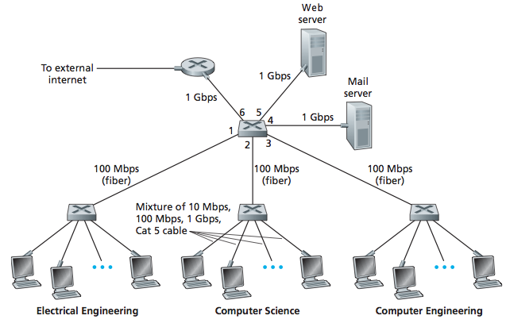

P23. Consider the above figure. Suppose that all links are 100 Mbps. What is the maxi- mum total aggregate throughput that can be achieved among the 9 hosts and 2 servers in this network? You can assume that any host or server can send to any other host or server. Why?
If all the 11=9+2 nodes send out data at the maximum possible rate of 100 Mbps, a total aggregate throughput of 11*100 = 1100 Mbps is possible.

P24. Suppose the three departmental switches in above figure are replaced by hubs. All links are 100 Mbps. Now answer the questions posed in problem P23.
Each departmental hub is a single collision domain that can have a maximum throughput of 100 Mbps. The links connecting the web server and the mail server has a maximum throughput of 100 Mbps. Hence, if the three collision domains and the web server and mail server send out data at their maximum possible rates of 100 Mbps each, a maximum total aggregate throughput of 500 Mbps can be achieved among the 11 end systems.

P25. Suppose that all the switches in the above figure are replaced by hubs. All links are 100 Mbps. Now answer the questions posed in problem P23.
All of the 11 end systems will lie in the same collision domain. In this case, the maximum total aggregate throughput of 100 Mbps is possible among the 11 end systems.

