Practice Problem 1) (Computer Networking: A Top-Down Approach 6th Edition: Chapter 3 P1)

Suppose Client A initiates a Telnet session with Server S. At about the same time, Client B also initiates a Telnet session with Server S. Provide possible source and destination port numbers for:

a. The segments sent from A to S.

Source: any Destination: 23

b. The segments sent from B to S.

Source: any Destination: 23

c. The segments sent from S to A.

Source: 23 Destination: answer from a.

d. The segments sent from S to B.

Source: 23 Destination: answer from b.

e. If A and B are different hosts, is it possible that the source port number in the segments from A to S is the same as that from B to S?

Yes

f. How about if they are the same host?

No

Practice Problem 2) (Computer Networking: A Top-Down Approach 6th Edition: Chapter 3 P3)

UDP and TCP use 1s complement for their checksums. Suppose you have the following three 8-bit bytes: 01010011, 01100110, 01110100. What is the 1s complement of the sum of these 8-bit bytes? (Note that although UDP and TCP use 16-bit words in computing the checksum, for this problem you are being asked to consider 8-bit sums.) Show all work. Why is it that UDP takes the 1s complement of the sum; that is, why not just use the sum? With the 1s complement scheme, how does the receiver detect errors? Is it possible that a 1-bit error will go undetected? How about a 2-bit error?

Note: Wrap around if overflow.

01010011 + 01100110 = 10111001
10111001 + 01110100 = 00101110

One's complement = 1 1 0 1 0 0 0 1.

To detect errors, the receiver adds the four words (the three original words and the checksum). If the sum contains a zero, the receiver knows there has been an error. All one-bit errors will be detected, but two-bit errors can be undetected (e.g., if the last digit of the first word is converted to a 0 and the last digit of the second word is converted to a 1).

Practice Problem 3) (Computer Networking: A Top-Down Approach 6th Edition: Chapter 3 P5)

Suppose that the UDP receiver computes the Internet checksum for the received UDP segment and finds that it matches the value carried in the checksum field. Can the receiver be absolutely certain that no bit errors have occurred? Explain.

No, the receiver cannot be absolutely certain that no bit errors have occurred. This is because of the manner in which the checksum for the packet is calculated. If the corresponding bits (that would be added together) of two 16-bit words in the packet were 0 and 1 then even if these get flipped to 1 and 0 respectively, the sum still remains the same. Hence, the 1s complement the receiver calculates will also be the same. This means the checksum will verify even if there was transmission error.

Practice Problem 4) (Computer Networking: A Top-Down Approach 6th Edition: Chapter 3 P14)

Consider a reliable data transfer protocol that uses only negative acknowledgments. Suppose the sender sends data only infrequently. Would a NAK-only protocol be preferable to a protocol that uses ACKs? Why? Now suppose the sender has a lot of data to send and the end-to-end connection experiences few losses. In this second case, would a NAK-only protocol be preferable to a protocol that uses ACKs? Why?

In a NAK only protocol, the loss of packet x is only detected by the receiver when packet x+1 is received. That is, the receivers receives x-1 and then x+1, only when x+1 is received does the receiver realize that x was missed. If there is a long delay between the transmission of x and the transmission of x+1, then it will be a long time until x can be recovered, under a NAK only protocol.

On the other hand, if data is being sent often, then recovery under a NAK-only scheme could happen quickly. Moreover, if errors are infrequent, then NAKs are only occasionally sent (when needed), and ACK are never sent – a significant reduction in feedback in the NAK-only case over the ACK-only case.

Practice Problem 5) (Computer Networking: A Top-Down Approach 6th Edition: Chapter 3 P19)

Consider a scenario in which Host A wants to simultaneously send packets to Hosts B and C. A is connected to B and C via a broadcast channel—a packet sent by A is carried by the channel to both B and C. Suppose that the broadcast channel connecting A, B, and C can independently lose and corrupt packets (and so, for example, a packet sent from A might be correctly received by B, but not by C). Design a stop-and-wait-like error-control protocol for reliably transferring packets from A to B and C, such that A will not get new data from the upper layer until it knows that both B and C have correctly received the current packet. Give FSM descriptions of A and C. (Hint: The FSM for B should be essentially the same as for C.) Also, give a description of the packet format(s) used.

This problem is a variation on the simple stop and wait protocol (rdt3.0). Because the channel may lose messages and because the sender may resend a message that one of the receivers has already received (either because of a premature timeout or because the other receiver has yet to receive the data correctly), sequence numbers are needed. As in rdt3.0, a 0-bit sequence number will suffice here.

The sender and receiver FSM are shown in Figure 3. In this problem, the sender state indicates whether the sender has received an ACK from B (only), from C (only) or from neither C nor B. The receiver state indicates which sequence number the receiver is waiting for.

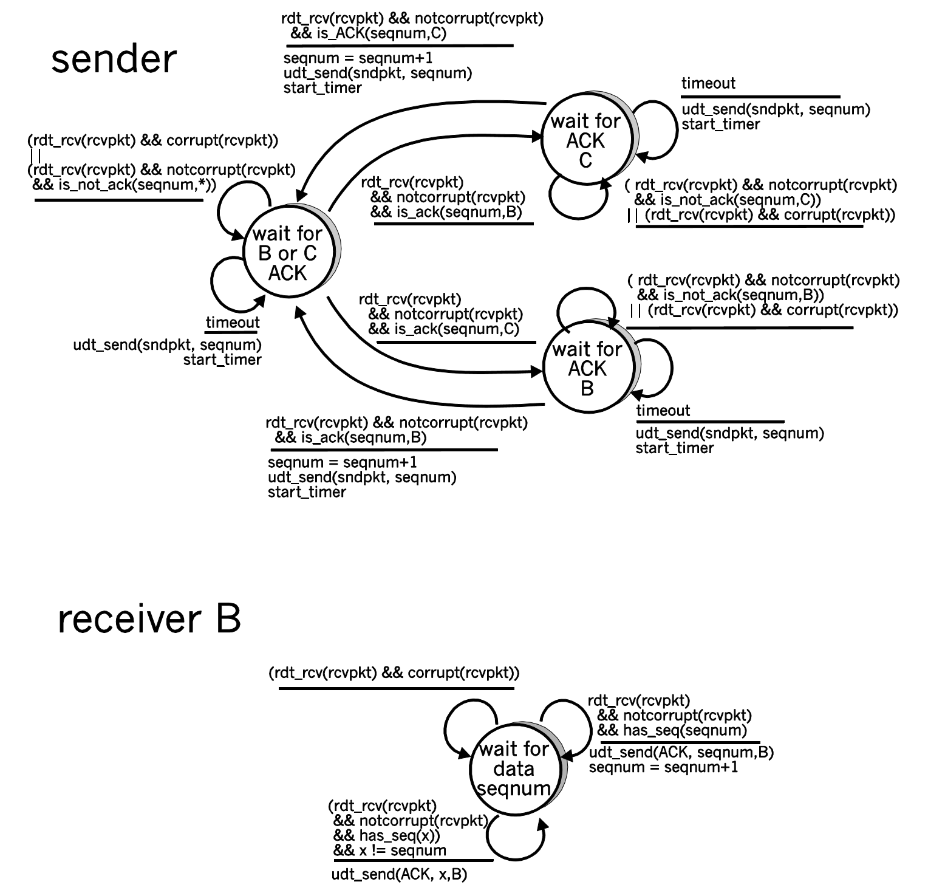

Figure 3. Sender and receiver for Problem 3.19 (Problem 19) (From Computer Networking: A Top-Down Approach 6th Edition Solutions Manual)

Practice Problem 6) (Computer Networking: A Top-Down Approach 6th Edition: Chapter 3 P22)

Consider the GBN protocol with a sender window size of 4 and a sequence number range of 1,024. Suppose that at time t, the next in-order packet that the receiver is expecting has a sequence number of k. Assume that the medium does not reorder messages. Answer the following questions:

a. What are the possible sets of sequence numbers inside the sender’s window at time t? Justify your answer.

Here we have a window size of N=3. Suppose the receiver has received packet k-1, and has ACKed that and all other preceding packets. If all of these ACK's have been received by sender, then sender's window is [k, k+N-1]. Suppose next that none of the ACKs have been received at the sender. In this second case, the sender's window contains k-1 and the N packets up to and including k-1. The sender's window is thus [k-N,k-1]. By these arguments, the senders window is of size 3 and begins somewhere in the range [k-N,k].

b. What are all possible values of the ACK field in all possible messages currently propagating back to the sender at time t? Justify your answer.

If the receiver is waiting for packet k, then it has received (and ACKed) packet k-1 and the N-1 packets before that. If none of those N ACKs have been yet received by the sender, then ACK messages with values of [k-N,k-1] may still be propagating back.Because the sender has sent packets [k-N, k-1], it must be the case that the sender has already received an ACK for k-N-1. Once the receiver has sent an ACK for k-N-1 it will never send an ACK that is less that k-N-1. Thus the range of inflight ACK values can range from k-N-1 to k-1.

Practice Problem 7) (Computer Networking: A Top-Down Approach 6th Edition: Chapter 3 P25)

We have said that an application may choose UDP for a transport protocol because UDP offers finer application control (than TCP) of what data is sent in a segment and when.
a. Why does an application have more control of what data is sent in a segment?

Consider sending an application message over a transport protocol. With TCP, the application writes data to the connection send buffer and TCP will grab bytes without necessarily putting a single message in the TCP segment; TCP may put more or less than a single message in a segment. UDP, on the other hand, encapsulates in a segment whatever the application gives it; so that, if the application gives UDP an application message, this message will be the payload of the UDP segment. Thus, with UDP, an application has more control of what data is sent in a segment.

b. Why does an application have more control on when the segment is sent?

With TCP, due to flow control and congestion control, there may be significant delay from the time when an application writes data to its send buffer until when the data is given to the network layer. UDP does not have delays due to flow control and congestion control.

Practice Problem 8) (Computer Networking: A Top-Down Approach 6th Edition: Chapter 3 P28)

Host A and B are directly connected with a 100 Mbps link. There is one TCP connection between the two hosts, and Host A is sending to Host B an enormous file over this connection. Host A can send its application data into its TCP socket at a rate as high as 120 Mbps but Host B can read out of its TCP receive buffer at a maximum rate of 50 Mbps. Describe the effect of TCP flow control.

Since the link capacity is only 100 Mbps, so host A’s sending rate can be at most 100Mbps. Still, host A sends data into the receive buffer faster than Host B can remove data from the buffer. The receive buffer fills up at a rate of roughly 40Mbps. When the buffer is full, Host B signals to Host A to stop sending data by setting RcvWindow = 0. Host A then stops sending until it receives a TCP segment with RcvWindow > 0. Host A will thus repeatedly stop and start sending as a function of the RcvWindow values it receives from Host B. On average, the long-term rate at which Host A sends data to Host B as part of this connection is no more than 60Mbps.

