Practice Problem 1) (Computer Networking: A Top-Down Approach 6th Edition: Chapter 2 P1)

a) F
b) T
c) F

Practice Problem 2) (Computer Networking: A Top-Down Approach 6th Edition: Chapter 2 P3)

Application layer protocols: DNS and HTTP
Transport layer protocols: UDP for DNS; TCP for HTTP

Practice Problem 3) (Computer Networking: A Top-Down Approach 6th Edition: Chapter 2 P7)

The total amount of time to get the IP address is

RTT1 + RTT2 + … + RTTn

Once the IP address is known, RTTo elapses to set up the TCP connection and another RTTo elapses to request and receive the small object. The total response time is

2RTTo + RTT1 + RTT2 + … + RTTn

Practice Problem 4) (Computer Networking: A Top-Down Approach 6th Edition: Chapter 2 P8)

a) RTT1 + … + RTTn + 2RTTo + 8 * 2RTTo = 18RTTo + RTT1 + … + RTTn
.
b) RTT1 + … + RTTn + 2RTTo + 2 * 2RTTo = 6RTTo + RTT1 + … + RTTn

c) RTT1 + … + RTTn + 2RTTo + RTTo = 3RTTo + RTT1 + … + RTTn .

Practice Problem 5) (Computer Networking: A Top-Down Approach 6th Edition: Chapter 2 P19)

a)
dig +norecurse @a.root-servers.net any soe.ucsc.edu
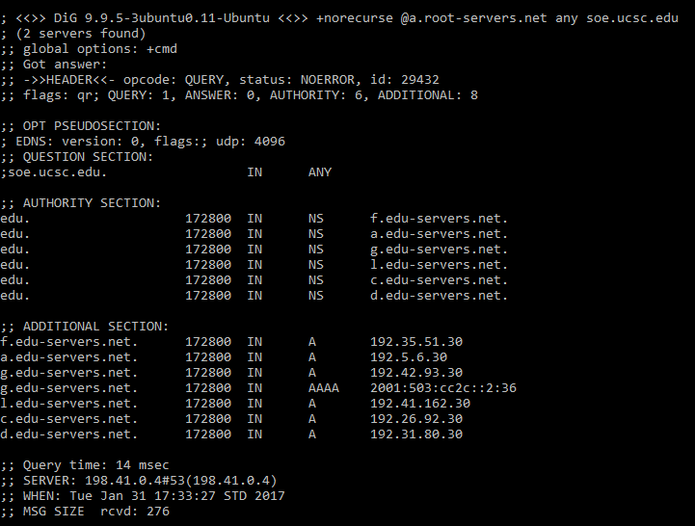

dig +norecurse @f.edu-servers.net any soe.ucsc.edu
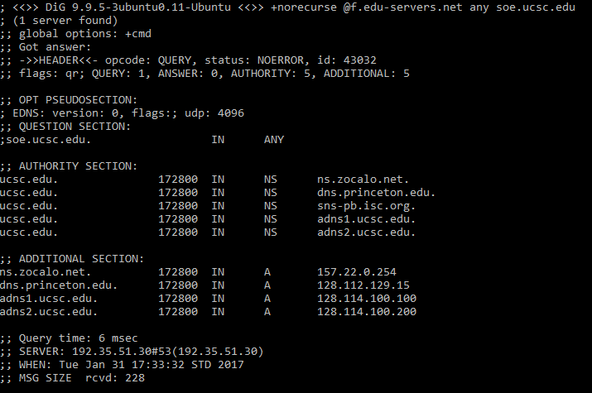

dig +norecurse @ns.zocalo.net any soe.ucsc.edu
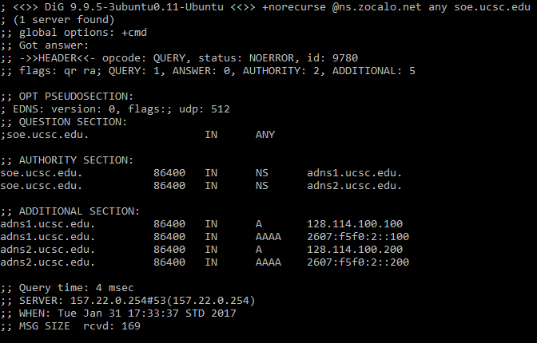

dig +norecurse @adns1.ucsc.edu any soe.ucsc.edu
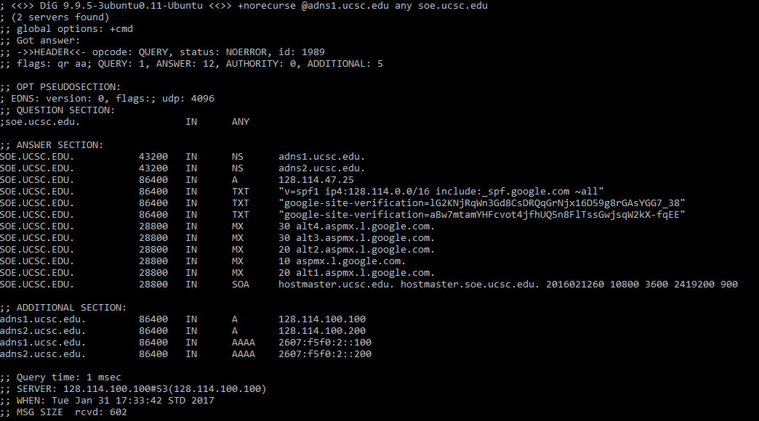

b)
The answer for google.com could be similar as above, using the nameservers:

a.root-servers.net
E.GTLD-SERVERS.NET
ns1.google.com

Practice Problem 6) (Computer Networking: A Top-Down Approach 6th Edition: Chapter 2 P20)

We can periodically take a snapshot of the DNS caches in the local DNS servers. The Web server that appears most frequently in the DNS caches is the most popular server. This is because if more users are interested in a Web server, then DNS requests for that server are more frequently sent by users. Thus, that Web server will appear in the DNS caches more frequently.

Practice Problem 7) (Computer Networking: A Top-Down Approach 6th Edition: Chapter 2 P21)

Yes, we can use dig to query that Web site in the local DNS server. For example, “dig cnn.com” will return the query time for finding cnn.com. If cnn.com was just accessed a couple of seconds ago, an entry for cnn.com is cached in the local DNS cache, so the query time is 0 msec. Otherwise, the query time is large

Practice Problem 8) (Computer Networking: A Top-Down Approach 6th Edition: Chapter 2 P22)

Client Server

 | 10 | 100 | 1000
300 Kbps | 7680 | 51200 | 512000
700 Kbps | 7680 | 51200 | 512000
2 Mbps | 7680 | 51200 | 512000

Peer to Peer

 | 10 | 100 | 1000
300 Kbps | 7680 | 25904 | 47559
700 Kbps | 7680 | 15616 | 21525
2 Mbps | 7680 | 7680 | 7680

Practice Problem 9) (Computer Networking: A Top-Down Approach 6th Edition: Chapter 2 P33)

Yes, you can configure many browsers to open multiple simultaneous connections to a Web site. The advantage is that you will you potentially download the file faster. The disadvantage is that you may be hogging the bandwidth, thereby significantly slowing down the downloads of other users who are sharing the same physical links.

